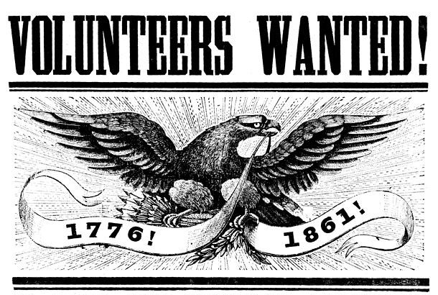
SUVCW
“Building a Leadership Program”
Workshop

If you are a Camp or Department Leader looking for ideas and strategies
you can use to build your own unique leadership programs, you are invited
to attend a workshop during the 2026 National Encampment, hosted by the
Department of the Chesapeake

Adams County Historical Society
Thursday, July 30, 2026
1:00 – 4:00 pm
(Registration of $15 for workshop will also provide
“Beyond the Battle” museum access afterwards)
LIMITED to 25 Attendees

For info and registration, contact: Brian W. Horgan, PDC
BHorganPA@aol.com
